Student Name: Prajalkumar Ramjiyani

Student Id: 12045947

Course name: Master of IT

Course Code: CC54

Tutor: Ahmed, Mahbub

**Output:**

Test 1:

Home Screen

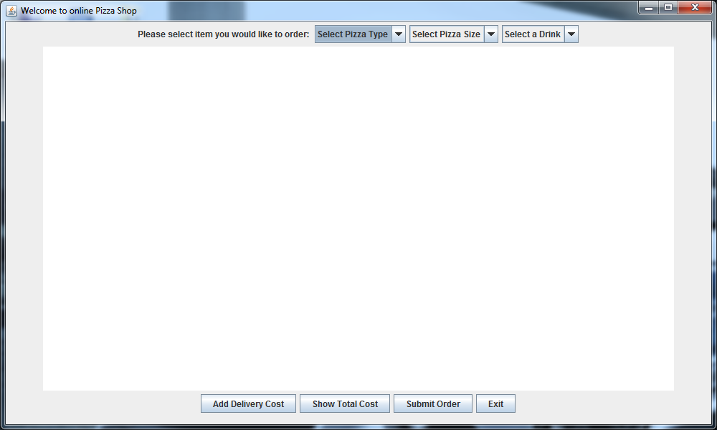

Test 2:

While Clicking on Add Delivery Cost button.

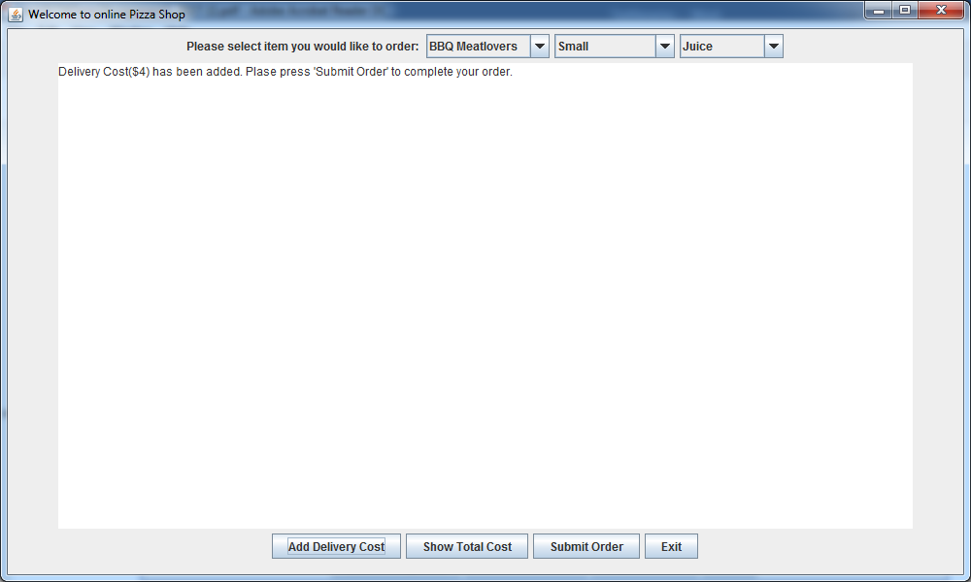

Test 3:

While Clicking on Show Total Cost button.

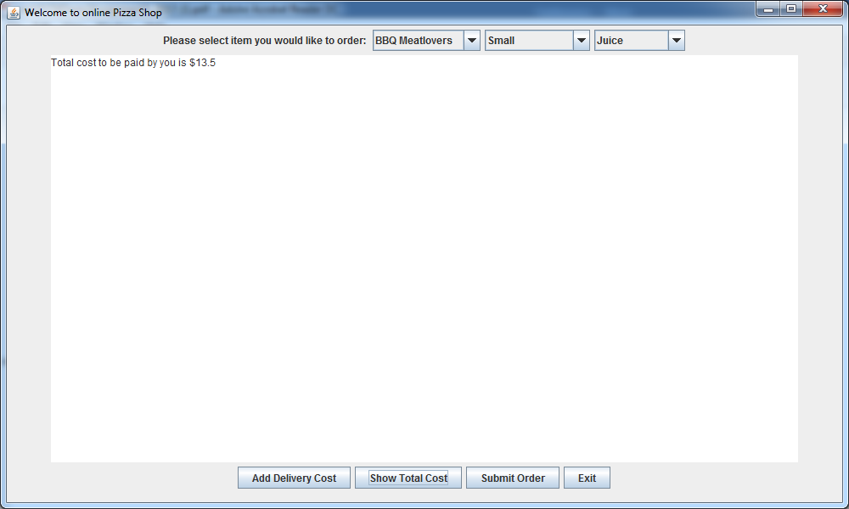

Test 4:

While Clicking on Submit Order button.

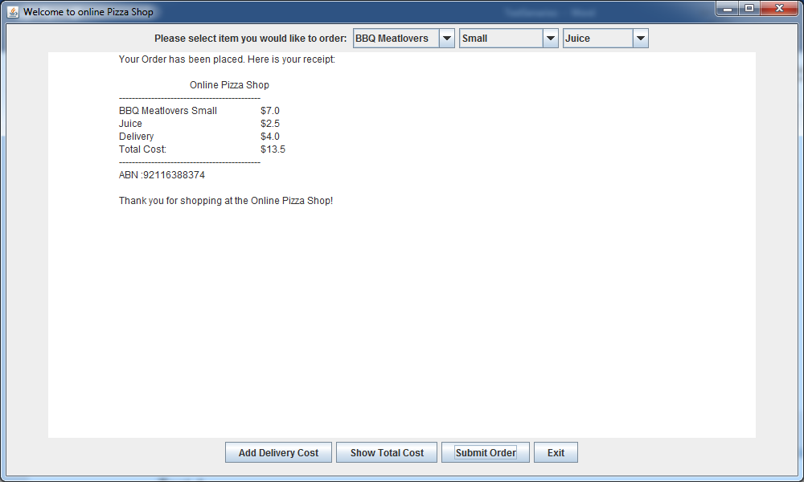

Test 5:

Without Delivery Cost with pizza and drink.

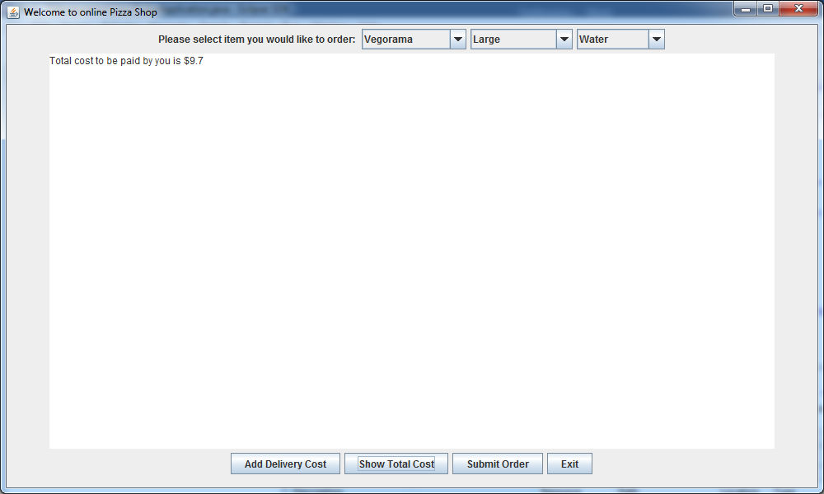

Test 6:

Without Delivery Cost order details.

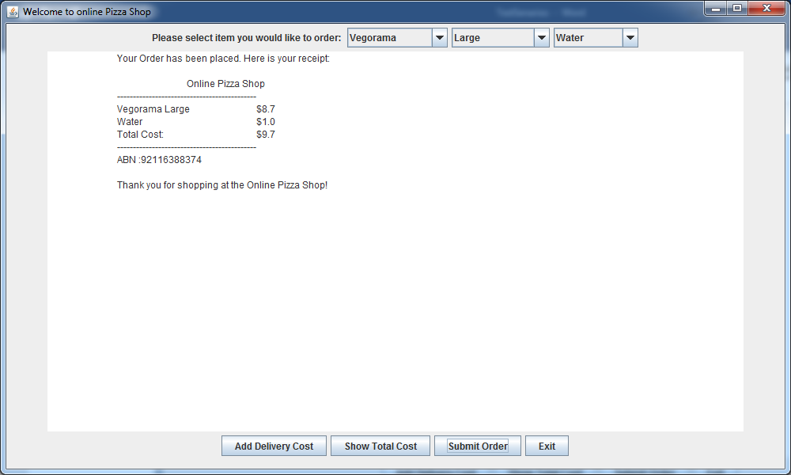

Test 7:

Validation while clicking on Add Delivery Cost button.

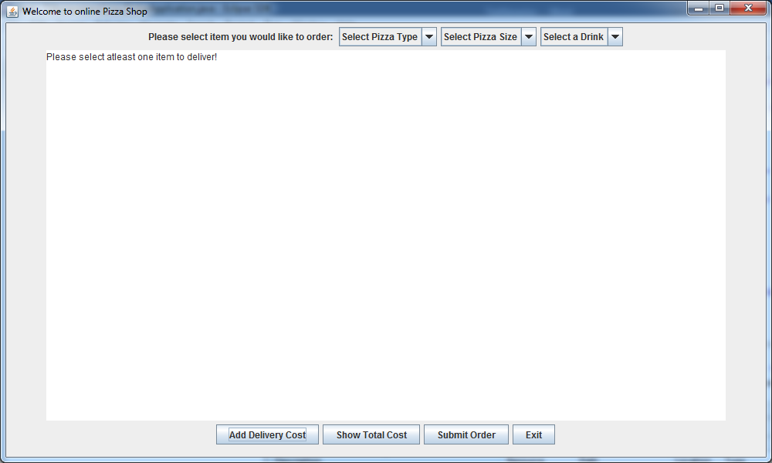

Test 8:

Validation while clicking on Show Total Cost button.

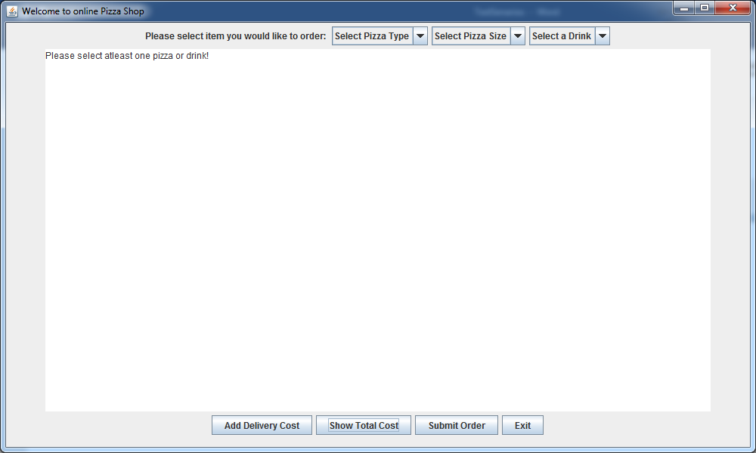

Test 9:

Validation while clicking on Submit Order button.

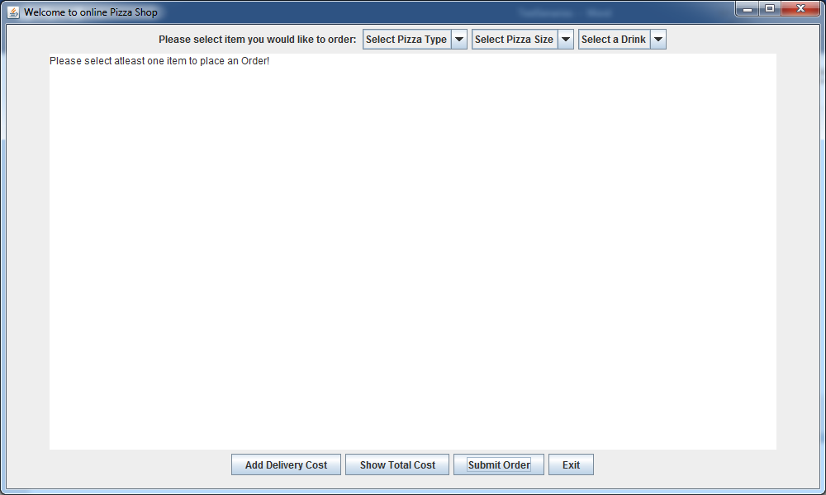

Test 10:

Validation If pizza is selected but not size so there is not item to deliver, same validation happen with other buttons.

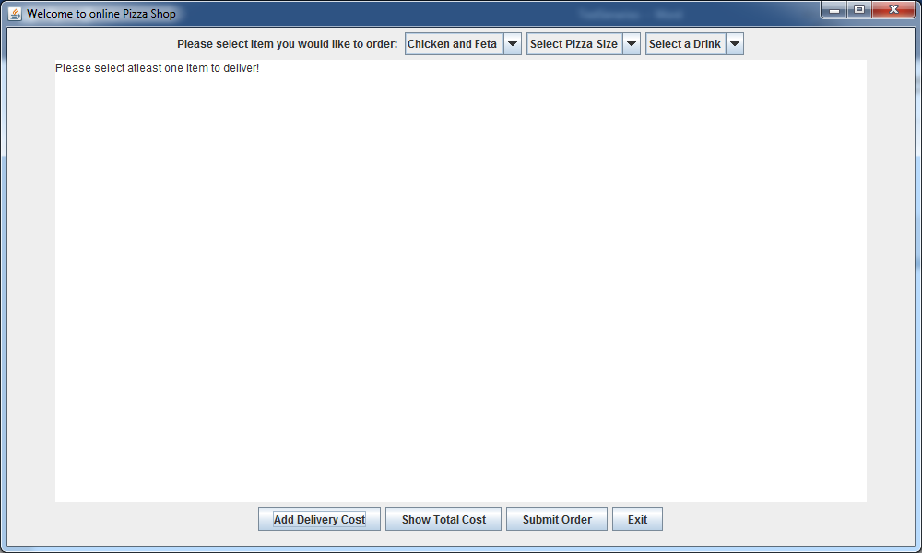

Test 11:

Validation while click on Exit button.

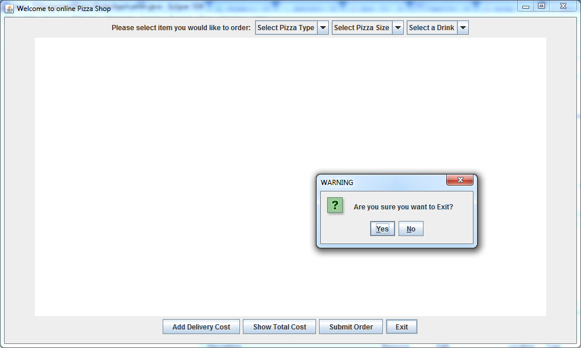

Test 12:

Only ordering Pizza with delivery cost.

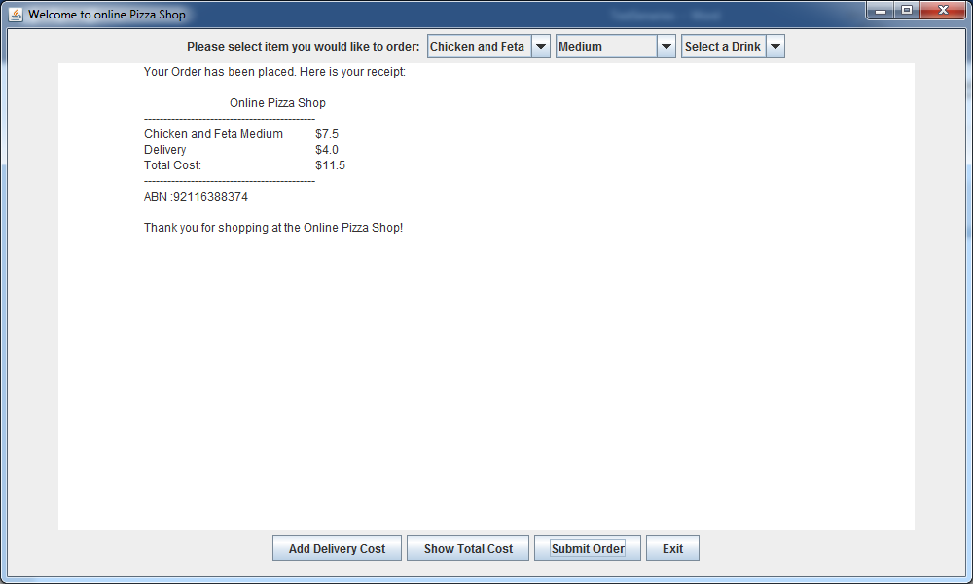

Test 13:

Only Ordering Drink with delivery cost.

